Model Development Phase

Date | 15 February 2026
Team ID | LTVIP2026TMIDS65517
Project Title | Advancing Nutrition Science through GeminiAI – NutriGen
Maximum Marks | 10 Marks

Initial Model Training Code, Model Validation and Evaluation Report

In the NutriGen project, no custom model training is performed. Instead, a pre-trained Gemini AI model is integrated to generate personalized nutrition plans and health guidance.
Initial Model Training Code:

Model Selection and Initialization

The Gemini Flash Lite (models/gemini-flash-latest) model is selected because:

- It is lightweight and optimized for fast inference

- Suitable for real-time personalized nutrition generation

- Efficient in handling structured health prompts

- Cost-effective for scalable deployment
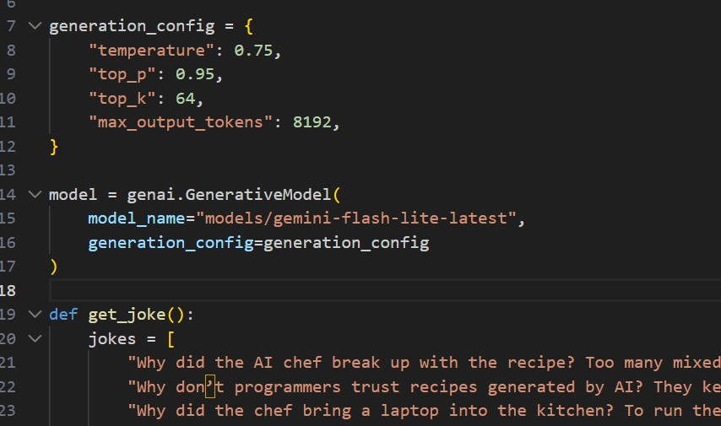

Model Validation and Evaluation Report:

Model | Summary | Training and Validation Performance Metrics
Gemini Flash Lite | Pre-trained generative language model optimized for fast text generation | Nutritional relevance, medical appropriateness, personalization accuracy, adherence to calorie targets, coherence, clarity, response time

